Helen Sanderson Associates Team Plan
Contents

- Our purpose, mission, values and principles
- Our history
- Our one-page strategy
- Our customer journey
- How we work together
- One-page profiles
- Our dreams
- What appreciation looks like to us
- How we communicate with one another
- Our person centred-team review

Our purpose, mission, vision and values

Our purpose is to be catalysts for person-centred change

Our mission is to have a global impact - to make a dent in history, through person-centred change.

The words that describe us, and our brand are:
- Passionate
- Authentic
- Innovative
- Creative
- Practical and approachable

Our values and principles are:

Thinking – we create an environment that enables us all to think well together and build capacity for change

Creativity - we work together to find creative, innovative ways to engage people and make a difference

Learning – we are committed to continual learning, sharing what we learn and always working to improve what we do and how we work together.

Authenticity – we use person-centred practices in our own lives and we strive to ‘walk our talk’ in how we work together as a team, and throughout all aspects of our work.

Relationships are everything – we work to develop great relationships with each other, our customers, our partners. We try to create a culture of appreciation and generosity. We co-produce our work whenever we can. We are honest and open, and we do what we say we will do.

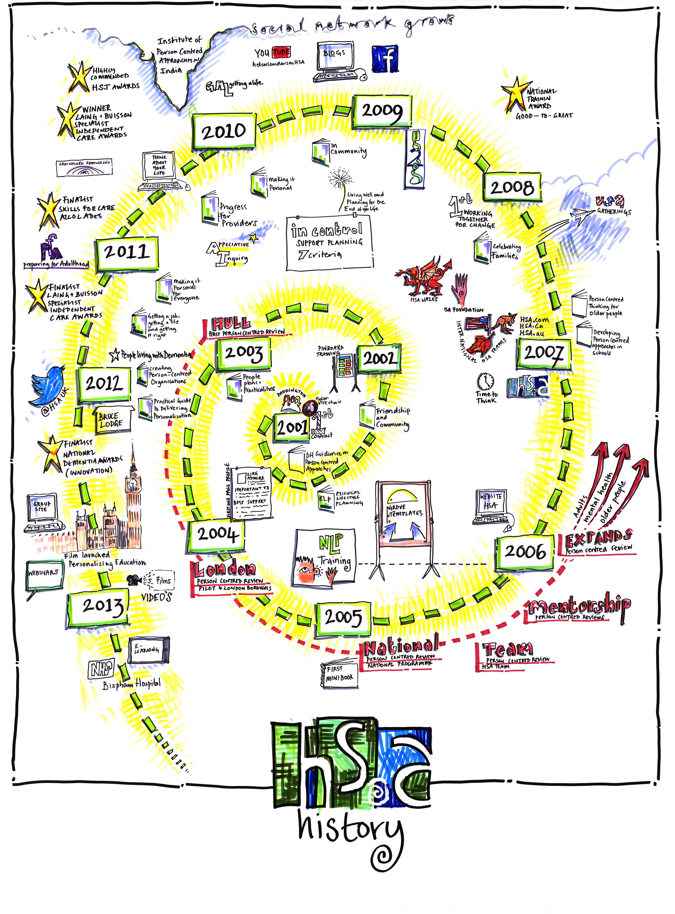
Our History
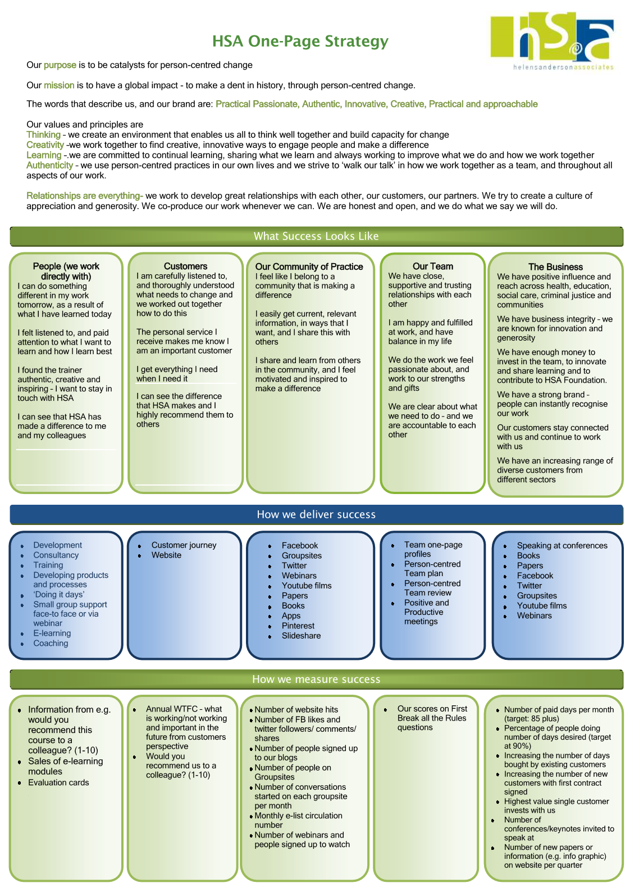

Our customer journey

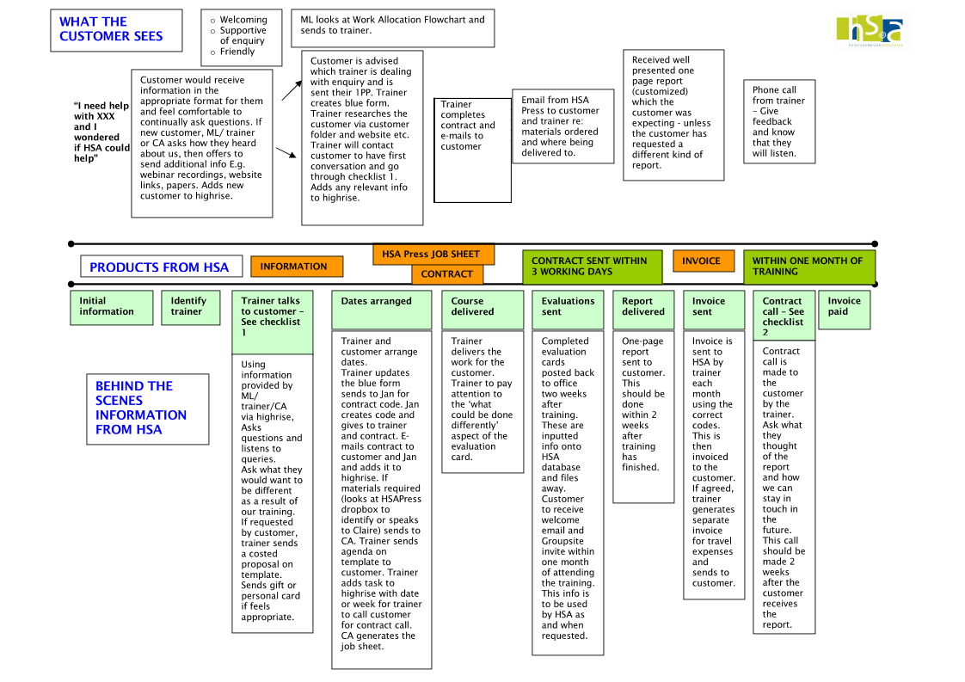
How we work together

Take care of ourselves and our wellbeing
We can only do our best work and make the biggest difference if we are looking after our own well-being. We trust each other to decide on how much work we want to do, when we do it, and to have enough admin time to deliver our customer journey brilliantly. We keep in a stretch zone but away from panic and staying in comfort (all the time)! Michelle’s role is to support us to be at our best so that we can deliver our best, and think about the 5 Ways to Wellbeing together. If we are struggling, we let each other know by sending out a “red alert” email which also says what good support from the team looks like (ie keeping emails to a minimum).

We are accountable– we do what we say we will do
We work together as colleagues, supported by Michelle but without a traditional management style. If we cannot deliver on a task, we let the person know before the deadline is missed. If you are struggling to get back to customers within three days, talk to Michelle.

Create an environment to enable people to think well together
In meetings, or on courses, create a welcoming, creative environment with colour (templates, posters), music and food. We are ‘multimedia practionaire’ in how we help people think and learn.

We dress and present ourselves in a way that reflects who we as individuals , and who we are in H S A. As HSA team members we are are creative, passionate about what we do, authentic, innovative, and approachable. We make sure that this shows in all aspects of our work, we know that people can do something different, or think differently, as a result of spending time with a team member.

Share learning
We can only demonstrate the difference we are making through the learning we share. We share responsibility for our facebook, twitter, blog and website presence.

Working together
Our philosophy is built on participation and co-production – in how we work together as a team and with customers. We co-design rather than write tenders, we do design days wherever we can. In working together as a team we pay attention to each other’s one-page profiles so that we know how to support each other well. We walk our talk by making sure our own meetings are positive and productive. We are accountable in our relationships with each other – and this means being prepared to challenge each other, and give each other constructive feedback. We all share the responsibility for delivering our purpose.

Change
Change is a feature of how we work. We see this as positive and healthy. Every year we set our strategic direction together – this will always involve changes to what we do, and how we do it.

How we make decisions in H S A

Who’s who in H S A?

- Helen in the CEO, and chair of the H S A Foundation
- Helen and Charlotte are the business owners
- Michelle is Minister of fun and quality support
- Associates are: Jo, Vicky, Jon, Gill B, Charlotte, Michelle, Ruth, Tanya, Petrea, Julia, Lou, Gill G
- H S A Foundation Trustees are: Helen, Jo, Vicky, Ruth

Who? | What decisions
Each team member | - How much work you aim to do (ie your personal target of how many days a month) and what you can do to bring this work in.  - How you want to grow and develop within the team, how you want to move towards your dreams.  - How you share your learning – and whether this is twitter, facebook, stories or blogs.  - Dates and times to meet with Michelle  - Which 5 relationships you invest in relation to your expert areas and to develop business  - How we invest in our learning as individuals
Associates | - Our strategic direction for the year, through our Business Planning  - Who else becomes an associate (decision-making by consensus)  - When and where to have meetings  - What goes in the team plan
Michelle | - What goes on the agenda for team meetings based on our AI goals and topics from 1-1 sessions (with Helen)  - Whether we go for any tenders we think we would consider going for because it feels “in shape” and that we have something to contribute  - How we deal with comments and concerns from customers
Helen and Charlotte | - As the owners of the business Helen and Charlotte review the company’s annual figures and make the high level financial decisions together.
Helen | - The strategic plan for key lead areas with the person who is leading this – developing annual outcomes together.  - What resources we use to deliver our purpose and strategy – eg communications support, IT support, how we use Julie Barclay’s time  - What partnerships we develop, who we introduce as partners to the team, who is proposed to the associates as a potential new associate  - What we development work we are able to pay consultants for

Our one-page profiles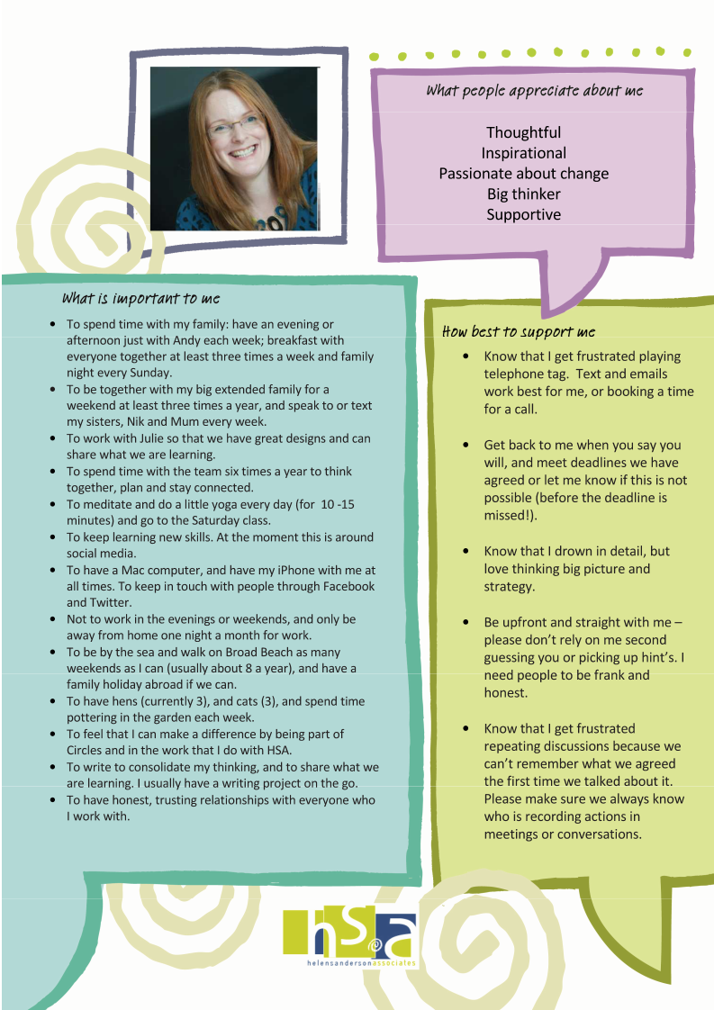
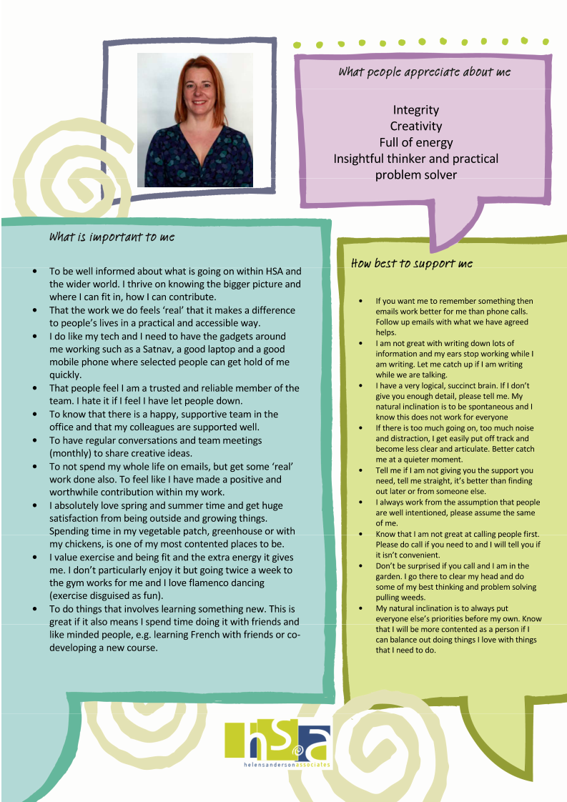
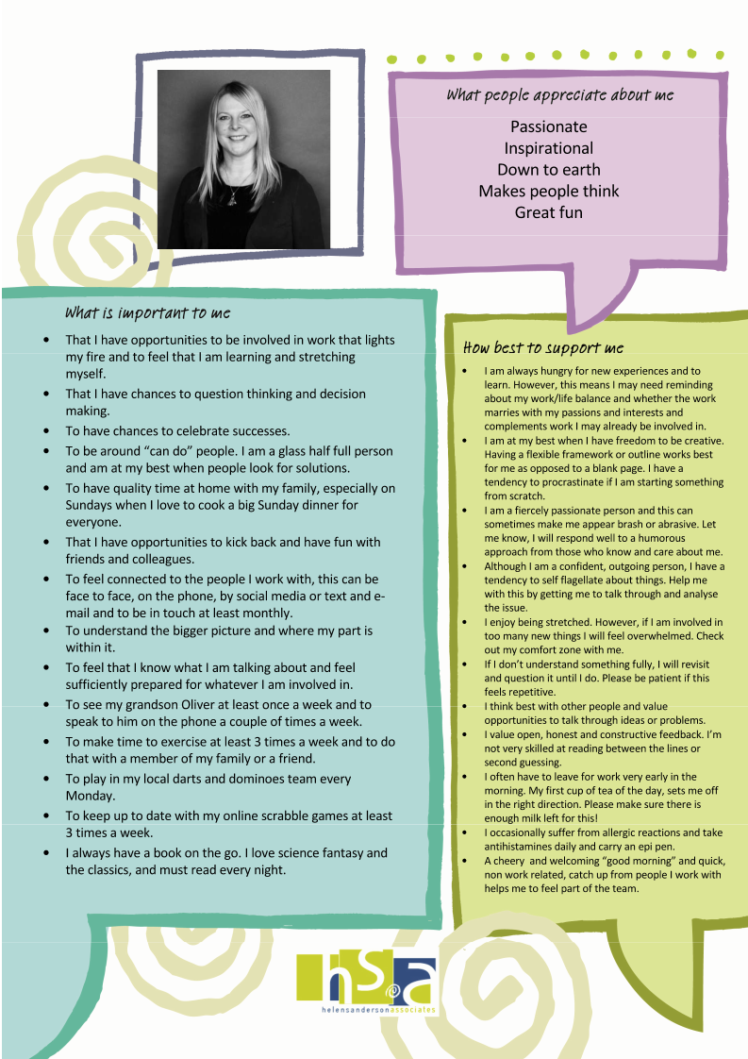
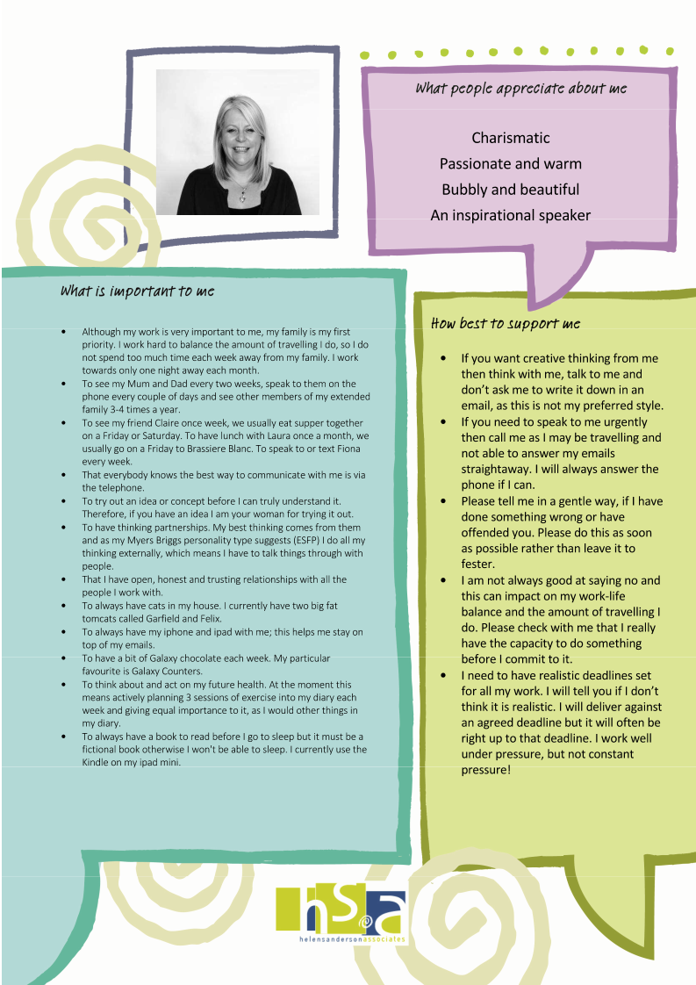
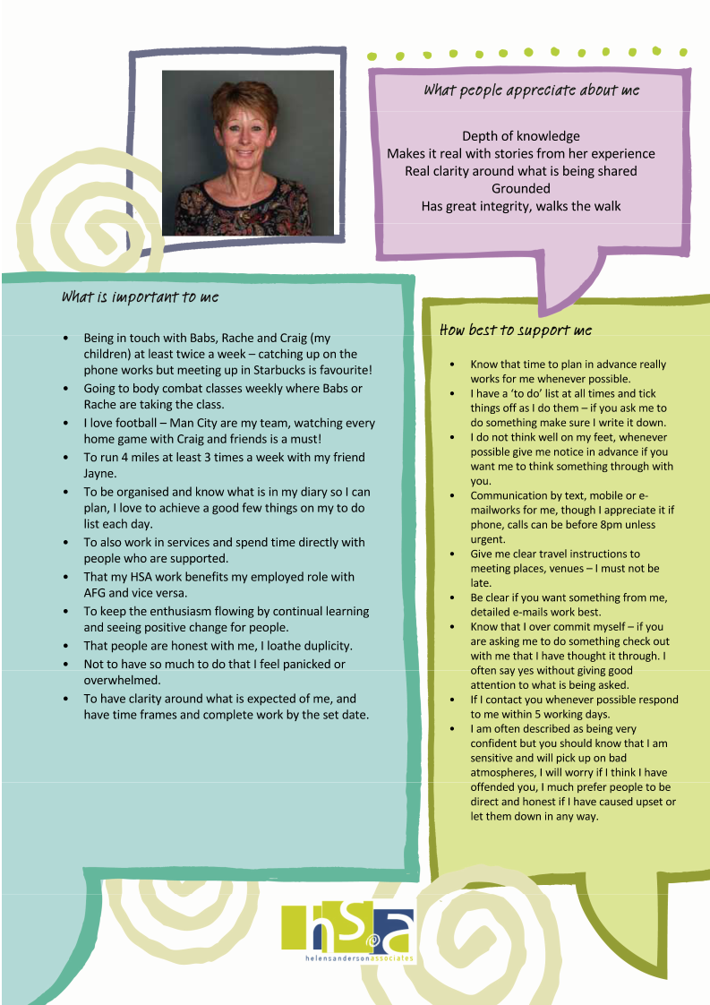
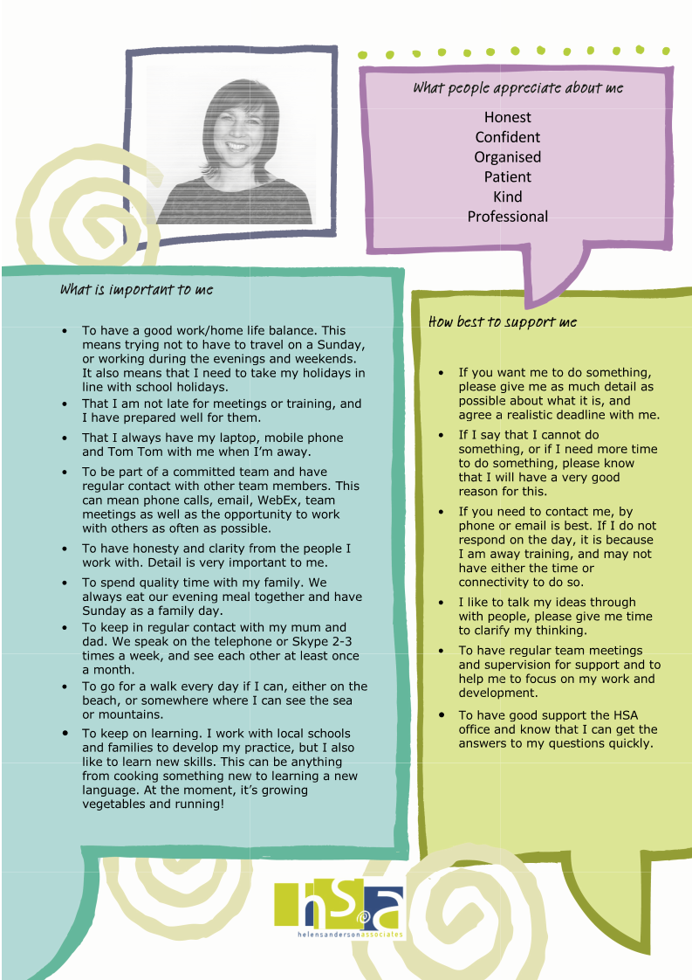
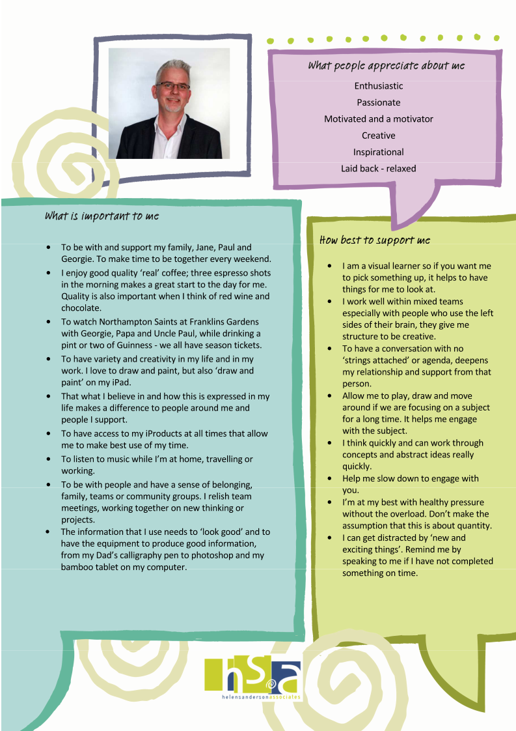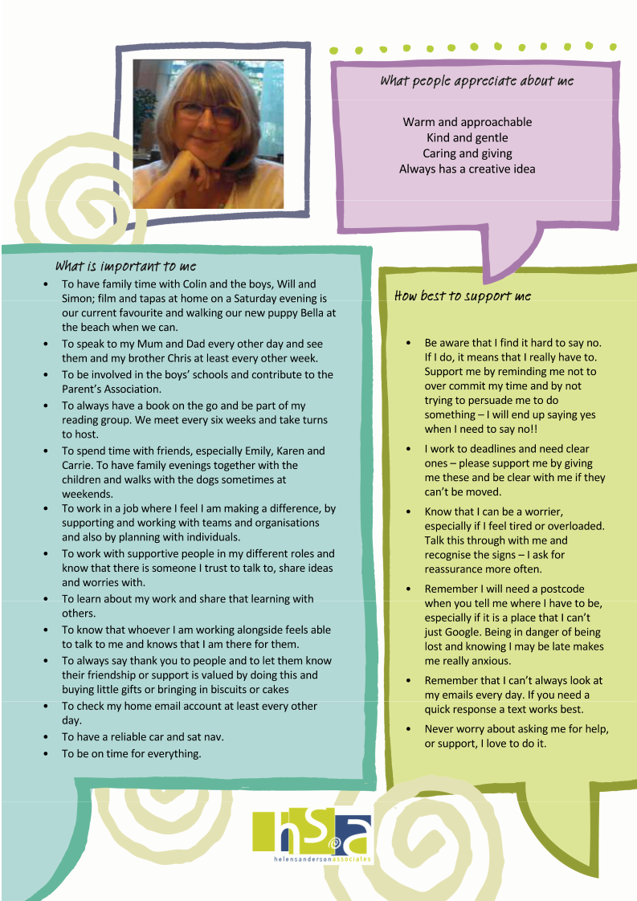
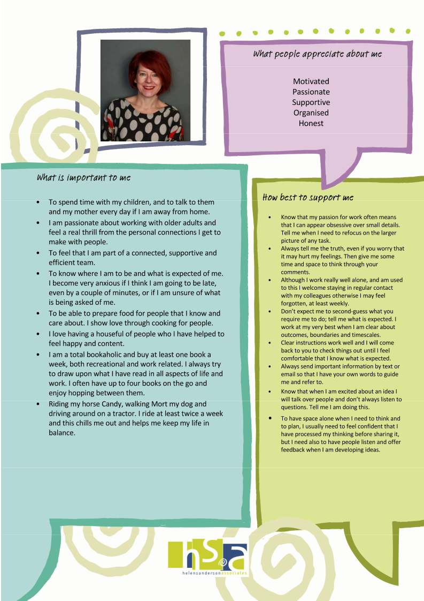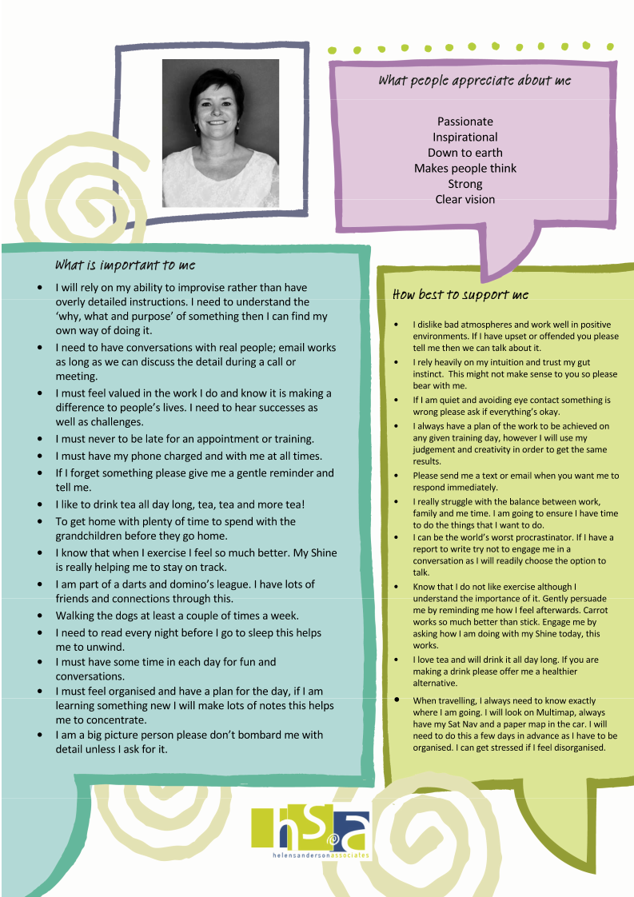

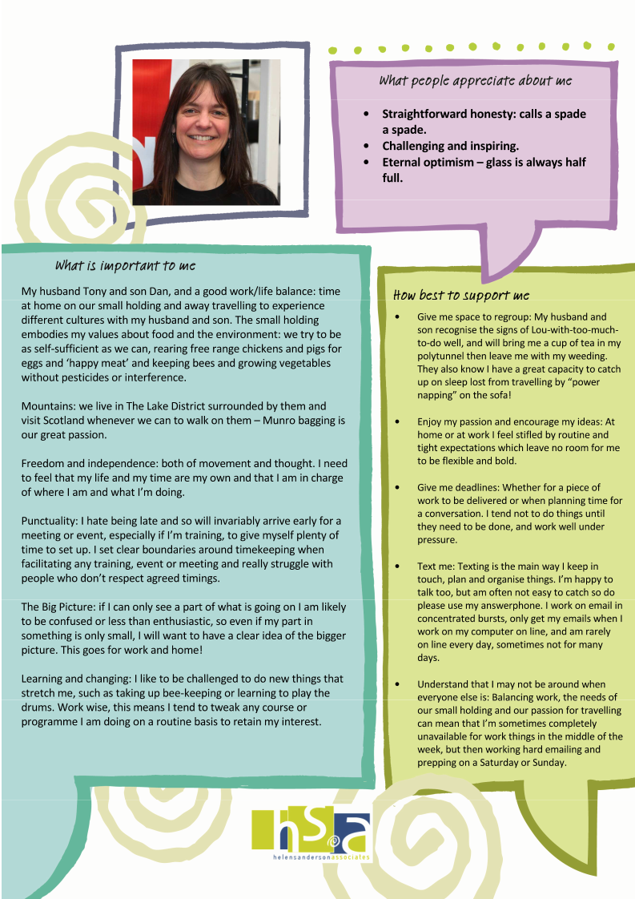

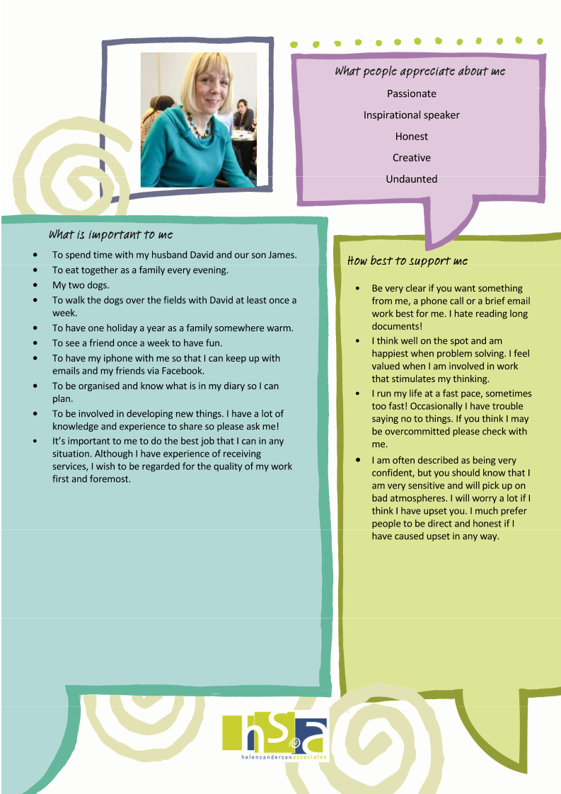

Our Dreams

Helen | To keep learning - To improve my writing and blogging to more effectively share H S A’s learning and contribution, and to be proficient in social media in promoting H S A  To not ever work in evenings (other than my Circle meetings and Antenatal class type things!)  To make the team proud of me!
Charlotte | To be firmly established as someone who makes a great contribution to the work around young people moving into adulthood, good relationships and connections and have things of real value to offer in this area  By the end of year, would like to get better at managing the financial accountability of HSA, so we can do some really sound financial planning and be more proactive around this, clarity around where to invest for example, if we do well at the numbers
Michelle | To see the difference that our work in HSA makes to vulnerable people  Not to work weekends, and to ensure my admin and prep is not done on a Sunday  Making time within working day to be active  To involve myself in learning that enhances my role within HSA and gives me some more credibility  To continue to work with people who stretch and inspire me  To always feel part of and contribute to a happy team and workplace
Jo | To continue to develop our reputation in planning in health, particularly in personal health budgets  To complete my coaching diploma this year  To travel less with work and have less days away from home  To take our work into new markets, trying our 'products' in completely new areas  To really get on top of my health issues
Gill B | That 100% of my work is with people with a dementia or older people, it’s important that I don’t feel like a jack of all trades and that I feel that I have an absolute focus on one area and am brilliant at my chosen field  To develop a best practice site in residential care, having opportunities to implement best practice  To have an evening a week and every weekend free of work. And to take regular holidays through the year  To do my masters through a dissertation based on the work I am involved in
Gill G | To write  To work abroad, Canada, USA or Australia – just for a short while not permanently!  To have time during the week to do the things that currently take up my evenings  To have not as many work hats and having the headspace to focus on education and learning disability  To feel like a contributing part of HSA
Jon | Really love the graphic recording and facilitation in real time, I want to grow this, use my gift to its full ability and become skilled in visual facilitation  To give back to my community being a member of Parent and Carers Association Milton Keynes.  Working in paid partnership with people with learning disabilities to deliver consultations / training
Vicky | Developing my skill level in what I do, things I am not up to date with and would like to be able to do more, e.g. WTFC. Figure out way to skill up, being confident in delivering a wider range of things  To contribute to writing a book  To continue to learn and develop in order that I can make a difference
Ruth | To continue to make a real difference for real people.  To find a better balance between work and family (especially grandchildren time as they are growing up very quickly).  To be a part of new developments I really enjoy this and it stretches me.  To have regular breaks with Peter.  To be a part of new developments or ways of working I really enjoy this.
Tanya | I have always been interested in the application of human rights within social care settings. I hope to be able to have work published that adds to the discussion of this topic, specifically within long term residential settings for people living with dementia  I have always had a n interest in history and philosophy and am combing those two interests by starting a combined History and Philosophy degree (part time) in September 2014 . I am hoping to focus on social history and draw from this to develop further work around social justice and the safeguarding of vulnerable adults.  I want to regain connection with Safeguarding in Kent , and to develop further the support available for people living with dementia in vulnerable situations through connection with front line practitioners and decision makers.
Louise | To regularly be involved in developing new things, for new customers, in new places and not to get stuck in a rut of delivering the same sorts of things for the same sorts of customers in the same places all the time. I love to be stretched and challenged and to be at the start of new projects and developments – then get to move on and do the next new thing before I get bored!  To do more facilitation events as opposed to just straight training – such as Good to Great, Working Together for Change, events, conferences, strategic planning… I’m told I’ve a real skill in facilitating large groups to think and work well together and as I love doing this, it would be great to do more!  To complete my Time to Think Foundation Course this July (2014) and consider further training after that if it fits me well.  To have space to work whenever I want and not when I don’t: for me that means sometimes working all day Sunday and Monday and Tuesday, including evenings, and then not for the rest of the week. The best thing for me about being self employed is being flexible to work when it suits me, spend time working on my small holding when it’s needed and travel when it works for us. Monday to Friday 9 – 5 is not for me!
Julia | To continue working in health and social care and to learn more about how person centered thinking can be used in other areas.  To continue my psychotherapy/hypnotherapy/counselling qualification and complete this in 2016  To keep weekends and evenings free to spend with my family

What appreciation looks like to us
Team Member | 1 | 2 | 3
Charlotte | Someone doing something for me | Seeing my work recognized by others | Text
Gill Bailey | Someone doing something for me | Phone call | Card/postcard
Helen | Text | Card/postcard | Small gift or flowers
Jan | Someone doing something for me | Seeing my work recognized by others | Small gift or flowers
Jo | Small gift or flowers | Text | Card/postcard
Jon | Being asked to share at conferences | Someone doing something for me | Face to face
Michelle | A thoughtful act | Small gift/token/ keepsake/card/postcard | Remembering my birthday
Ruth | Card/postcard | Face to face | Phone call
Vicky | Phone call | Card/postcard | Face to face
Gill G | Text | Card | Thoughtful gift
Tanya | Text | e-mail | Card
Louise | A text is best – my number one mode of communication | A phone call or email telling me what exactly I did that was good! | A card in the post
Julia | A thank you phone call or text | Seeing my work recognized by others | Small gift of flowers

How we communicate with one another

Who | How we can best communicate together
Charlotte  Home: 01865 820612  Mob:07976 897393  Heath House  Faringdon rd  Southmoor  Abingdon  OX13 5BG  charlotte@helensandersonassociates.co.uk | I like e mail as I am more likely to remember what was agreed. I check most days but less at the weekends. I do not take offence at being reminded of things I have forgotten.  Phone me anytime but I will be more distracted after 3pm as I will have Freya around.  I check facebook regularly so that’s a good way for keeping me informed about the general news from people.  I am appalling at sending out letters and cards, sorry.
Gill Bailey  21 Ringwood Ave  Audenshaw  M34 STB  M 07970 909463  gillianbailey32@hotmail.com | E mail works best for me, particularly if you are asking me to do something. Likewise text is OK as it is written down. I check email most days. Send me a text if it is something urgent in case I am working away and have no e mail. I like to catch up via telephone usually whilst travelling if I have been away or between 5 and 7.30 pm. I prefer people to not ring after 7.30 unless it is urgent.
Gill Goodwin  37 Kings Road  Higher Bebington  Wirral  CH63 5QQ  M 077955 66110  gillg@helensandersonassociates.co.uk | If you need a quick response text me. Although I try my best to check my e-mails every day, please bear in mind that I have a role outside of HAS which takes up more than half of my week which means I can’t always respond immediately as I will be working on other things. I appreciate being able to talk ideas/ issues through, although I may not particularly need advice (I will ask if I do), I do need to process my thinking externally.
Michelle Livesley  7 Norwood Ave  Lowton  Warrington  WA3 2AE  M:07854669488  michelle@helensandersonassociates.co.uk | My preference for communication is to have a conversation; this is how you will get the best from me. This can be either in the same room, on the telephone or computer. However, my poor memory means that I need any agreed actions to be followed up by email, I can’t abide junk emails though especially those “pass it on to 10 million friends” ones. Please don’t be offended if my email style seems curt, I’m not good at e-niceties. Receiving text is ok but I rarely send texts, I’m too slow and it’s too fiddly.
Ruth Gorman  19 Dean Road  Golborne  Warrington  Cheshire  WA3 3PQ  M 07779795847  ruth@helensandersonassociates.co.uk | I prefer face to face/telephone conversation as opposed to e mail. If you need to get info to or from me urgently, what works best is to text or phone me –anytime suits really. I do my best thinking when I’m talking and having conversations, not necessarily writing it in an e mail. I use my phone for all my emails as wel as my computer. I always have my phone with me and check as soon as I hear the message or email alert. If you send me something during the weekend I will open it be could have forgotten by Monday. I am trying hard to respond immediately or put straight into a folder that I will deal with on Monday. The problem with this is I am constantly working, trying hard to get out of the habit.  I do not do Facebook/Twitter etc. it is a personal choice as I dislike it with a passion.
Helen  34 Broomfield Road  Heaton Moor  Stockport, Cheshire  SK4 4ND  T 0161 442 8271 (office)  F 0161 442 8271  M 07958031419  helen@helensandersonassociates.co.uk | I work best by e mail. I check my e mail Monday to Friday. Text is a good way to get me during the day and definitely if you need something urgently. I work hard to keep my evenings and weekends work free so only phone me at home in emergencies please.
Jo  Home:01242 515174  Mob:07879468232  155, Cirencester Rd,  Charlton Kings,  Cheltenham  Glos. GL53 8DB  jo@helensandersonassociates.co.uk | I prefer most of our communication to be via telephone calls. The best number to phone me on is my mobile and I will tell you if it is convenient to talk as this may be dependent on travelling and children.  Anything you need me to do or we have agreed together needs to be confirmed by e-mail by either of us to provide a record or a gentle reminder. I do not take offence at being reminded of things I have forgotten.
Jon  68 Frampton Grove  Westcroft  Milton Keynes  MK4 4GE  M 07708442503  jonathan@helensandersonassociates.co.uk | I like short paragraphs of information with images that support the text - colour is also important. A graphic on one page communicates an idea better to be than a chapter in a book.  I'm happy to communicate with people but not after nine in the evening or at weekends unless we agreed and planned a time to talk.  Try put the purpose of the email in the subject line. If it's a decision for information etc. keep the emails short but be clear. Make sure your intentions are clear. This is best for me if larger bits of information that I can take time to read.  If you need to talk to me on the day realise that I may be training and the phone will often go to voicemail. If you leave a voicemail please let me know why I need to phone you back. Phoning is good for checking on my progress for agreed actions.  Many people send me a text as they need a quick response - happy that this is used in this way. I love Facebook and other social media I like to see what my team mates are doing and it's a good way to keep in touch when working in a virtual team.
Tanya  25 Castle Avenue  Dover  Kent  CT16 1HA  07979140644  Tanya@helensandersonassociates.co.uk | Best way to communicate with me is always in the written form -and email preferable to text as I can print them easily.  I prefer clear and simple instructions, and would not be offended if there were no “social chat” attached - though I will respond to social chat.  I would like my colleagues to know that although I will not initiate chat for the sake of it either via email or text or phone it is not because I am uncaring, just insular.
Louise  Croft Barn  Lorton  Cockermouth  Cumbria  CA13 9UW  07729127173  louisec@helensandersonassciates.co.uk | By far the best way to communicate with me is on my mobile, even better by text, even if it is to plan a telephone call to have a proper conversation about something. Whether I am working at my desk in my study, weeding my polytunnel, cleaning out my chickens, playing with my pigs or walking up a mountain my mobile is always in my pocket and I text continually. Even when I’m training I check my phone at coffee breaks and lunch and before I set off for home, so it is by far the best method of getting hold of me. I work very flexibly so I can be working at any time of the day, any day of the week – equally I can be not working when everyone else is, and it’s important that people know this and don’t simply expect me to be available because they are. I only pick up emails on my lap top when it’s on line, and that is rarely every day, sometimes not for several days, but when I work it is usually in bursts and I’ll make up for it by sending dozens of emails in a short space of time! My home number is exactly that – home, and I only invite HSA people to use it for booked calls, never when I’m not expecting it and never for customers please!
Julia  2 Paddock Drive  Chelmsford  Essex CM1 6SS  M 078412855230  juliaw@helensandersonassociates.co.uk | I prefer communicating face to face, but this is not always practical so telephone calls work best for me. Please use my mobile number for this.  A brief email to confirm any agreed actions really helps.  If I have a lot going on I may forget things and I appreciate gentle reminders
Rob Michael-Philips  37 Downs Park  Downley  High Wycombe  Bucks,  HP13 5LU  07971054413  rob@helensandersonassociates.co.uk | My preferred means of communication for larger things I need to do is e-mail, or a phone call followed up with an e-mail. This way I can keep everything in one place and refer back to it easily. It confuses me massively if I ask a question by e-mail and get the response by text! For anything else then I don't really mind how you get hold of me.  If possible, can I have one e-mail per subject. I can sometimes miss stuff if there are is an instruction/request buried in the middle of a long e-mail. I communicate like this too, which is why you might get 3 e-mails about different things rather than 1 long one about 3 things.  My usual style if I have a number of things to discuss would be to make a number of phone calls rather than one big one, but this isn't the most practical thing. If we're going to be talking for a while, it might be best to let me have a short break in the call to let me check where I am with things.  I will sometimes get excited by a half formed idea and try to talk to someone about it without doing any research or considering what previous practice might have been. Be nice to me if I do this, it's only because I'm keen.  E-mails, tweets and texts etc pop up on my phone throughout the day and I check them whenever they come in. I'm not good at compartmentalising things, so if there is anything that I might construe as bad news I'd appreciate it coming during office hours, if not for my sake, then for the sake of my family!

Stress and Support – Helen

What makes me feel most stressed? | How do I usually react to being stressed? | What helps?
 |  | What can I do? | What I would like you to do?
When I have more work than I can manage – and my diary is full with back to back meetings | Sleep badly and wake up in the middle of the night  Become snappy and critical  Looking at/answering emails all evening to try and catch up | Make sure my action book is up to date and I have prioritized by actions  Get better at saying no to things or asking others to pick them up where appropriate  Make sure I am booking in 20 mins between meetings and calls | If you notice that you have got an email before 7.45am ask me how I am sleeping  Be clear with me if you are able to pick work/tasks up – would feel awful if I felt I was pushing things on people that they did not want to do
When I don’t have the information that I need to do my job well | Assume things are not happening if I am not given information to the contrary | Ask directly for people to get back to me at a certain time/date with the information I need | If you don’t have the information I need, please respond with when you will have it (instead of waiting until you have it and then sending it to me)
When I suspect things are not right (in relationships) but don’t know for sure | Start to become a bit paranoid! | Ask directly when I can | Please be direct with me and tell me as soon as you can if I have done something to upset you. I would prefer to know directly rather than hear about it from someone else. Please don’t hint – please be direct.  Please share the responsibility with me for our relationships being good and strong.

Stress and Support - Charlotte
What makes me feel most stressed? | How do I usually react to being stressed? | What helps?
 |  | What can I do? | What I would like you to do?
If I am not clear about something, what is expected of me, and I will procrastinate, | I ‘mull’ things over constantly in my head, internal dialogue with myself so I can appear distracted, | Pull weeds in the garden, walk dog, to get a bit of head space. Talk to someone who can ask good incisive questions.  Deal with my frog first thing  Keep lists | Give me space/time to think when I am appearing really distracted
Feeling insecure and anxious. Feeling what I am doing is not good enough or inadequate. Thinking there is a hidden agenda, people not sharing honestly what they feel so I am left guessing or worrying, | Waking early and restlessly, I get three day headaches, stop doing any exercise and shoulders creep up, I eat badly and skip meals. Mulling things over in my head | Check out assumptions, be brave. Get some fresh air. Talk to someone objective, not part of the situation to help me get perspective. | Honest timely feedback.  Ask me how I am
Not having space to do things without constant interruptions, | Snappy and irritable with my family, | Count to 10! | Don’t go to me first to ask for things, try to figure things out first and then check If you still need to.  you’ll get better quality thinking if you can find a time where I am not having my attention split, e.g when several conversations are going on at once-I really struggle to follow things if it gets chaotic
Not having a clear deck around me, feeling reasonably on top of my home environment, childcare, reasonable tidiness | I get constantly distracted, I feel out of control and irritable  I snap at my family | I work till late at night which helps calm me, but only if I get enough sleep the next day. | For my family-lots  If on the phone, I am usually multi tasking clearing up at the same time. Don’t be alarmed by strange noises.
Feeling like I am being ‘nagged’ or not allowing me to sort my own priorities | If I am stressed because I feel I am ‘dictated’ to I may start to react a bit like a teenager, dig heels in and get uncooperative. | Tell people this is the effect I am experiencing | Adult to adult conversations definitely work better, be clear and honest about what is going on.

Stress and support-Michelle

What makes me most stressed | How do I usually react to being stressed | What helps
 |  | What I can do | What I would like you to do
Feeling overwhelmed | I’ll be working on Sundays too keep on top of my to do list.  I’ll experience bad sleep patterns and have stress dreams.  I become impatient, less diplomatic, snappish.  Become more forgetful. | be more realistic how much time things take | Ask me if I am feeling on top of things.  Having really good recorded decisions and actions helps me.  Checking out how my Sundays are to prompt me to look at my behaviour, asking me how my fitness is going
Unsure/unclear about what I am supposed to be doing | Takes me much longer to respond to queries or I procrastinate. | Continue to ask questions until I am clear. | Be patient with my questioning. Check out with me if I have enough information.

Stress and support-Jo

What makes me most stressed | How do I usually react to being stressed | What helps
 |  | What I can do | What I would like you to do
Under estimating the amount of time it will take me to do something, particularly writing and then not having enough time to do it | I will work evenings and weekends to catch up on work, then feel over stretched and frustrated. | Be really clear that these sort of tasks take me longer than it may take other people, negotiate this and then schedule the appropriate amount of time in my diary as if it is a days training. | Understand this make take me longer than it may take others and make sure I am scheduling it in my diary.
Feeling overwhelmed with the amount of admin work I have and not enough time to complete it all. | I will work evenings and weekends to catch up on work, then feel over stretched and frustrated. | Be really clear that these sort of tasks take me longer than it may take other people, negotiate this and then schedule the appropriate amount of time in my diary as if it is a days training. | Understand this make take me longer than it may take others and make sure I am scheduling it in my diary.
Feeling overwhelmed with the amount of admin work I have and not enough time to complete it all. | I get so overwhelmed that I end up not doing anything as I can't see where to support | Use my coding process on my to do list every day so I am clear what I need to do.  Ensure I always have an admin day each week.
When people don't listen to me and what I am trying to say. Not being heard. | I will either be angry and then be more vehement in what I am trying to say, I may come across as angry or I will completely shut down. This I do when I am very stressed about a situation. | Prepare myself well when I want to say something which is important to me. Self coach myself to prepare. | If I appear to be angry about an issue or withdrawn, understand that I don't feel I have been heard. Please give me the time and space to say what I need to say.
Not being really clear on what I am supposed to be doing | I will procrastinate and not get on with the task. | Always check that I am really clear what I need to do | Please talk it thorough with me again, even if you have done this before.

Stress and support- Gill B

What makes me most stressed | How do I usually react to being stressed | What helps
 |  | What I can do | What I would like you to do
Lack of it skills e.g. not being able to save u tube clips to computer

Overestimating my capacity which means I can over promise and not deliver. | Feeling guilty and disappointed in myself for letting others down. | Improve how my calendar looks and put realistic time scales against projects and tasks. | Give me time to reflect on whether I can pick up a piece of work, ask me if I have enough time to do it.
Entering new areas of work when I don’t have enough information/ learning to deliver with integrity. Not having detailed trainers notes and stories/ examples to share. | I will feel pressured and work evenings and weekends to fill the gaps, which will make me feel overstretched. | Ask for the help that I think I need. | Having a face to face meetings dedicated to filling the gaps in my information with the relevant person.
Not being aware of some of the creative exercises that other team members have developed. | I will feel inadequate and worry that I’m not doing the best job that I can. | Ask people to share anything new with me. Make sure I actively share my learning with the team. | Make sure we share our learning via team meetings, u tube, drop box ,e-mail.
When others don’t follow up on their actions and this affects my ability to do what I need to. | I would stew on it, feel like a nag before eventually throwing it away. | Continue to chase. | Acknowledge the e-mail and let me know when you are able to get back to me.
If my e-mails are not responded to in a timely fashion.

Stress and Support – Gill Goodwin
What makes me feel most stressed? | How do I usually react to being stressed? | What helps?
 |  | What can I do? | What I would like you to do?
Having too much on the go at one time. I love being busy but sometimes can take on too much. | I go into “I am responsible for everything” mode and worry that I haven’t done something that I should have or feel that anything I am involved in that hasn’t gone well will be because of my bit. I start double checking things or ask others to check things that I would usually not need reassurance about. I struggle to switch off. | Recognize that I have too much on. Ask to talk things through with someone. Say no if asked to do something else. | Notice if I start to ask for reassurance about things I wouldn’t usually and ask me how things are going. Know that I find it hard to say no, so if I do it’s because I really need to. Know that it will have been really difficult for me to say no in the first place.
If I think I’ve done something that I could have done better. | I will go quiet and seem a bit low. Be subdued. | I prefer to take time to think it through and then seek someone specific to discuss this with. If I know it is an irrational concern I may just keep it to myself and it will blow over. | I would prefer to go to someone to talk this through rather than be asked.
Not having the opportunity to talk things through if there has been disagreements or misunderstandings or if  I’m worried about something and need to talk about it. | I’d worry about this, but would act on it as soon as possible. | Continue to do this. | Be available to talk it through as soon as possible as this will prevent me from worrying about it until we talk.
Going into consultation or training were I don't feel I have examples, stories and therefore integrity and street cred to be able to deliver it.  Not having control over content. | This rarely happens as I am clear about my capabilities. | Trust myself to do what I can do, I usually know when things are ok to do or not.  I feel better about new work if I can design it. | Don't try to persuade me to deliver something that I don't feel I know enough about – please trust me on this  If I am going to deliver something that feels new, know that I will need to make it feel like my own and make a contribution.
Concerns about childcare. | Moaning at Colin about keeping his diary up to date. | Staying on top of mine and Colin’s diaries.  Not say yes to the work if I’m not sure about childcare. | Continue with the way this happens now – HSA feels very family friendly to me

Stress and support-Jon

What makes me most stressed | How do I usually react to being stressed | What helps
 |  | What I can do | What I would like you to do
Putting too many expectations on my time and setting unrealistic tasks | I go quiet and my general levels of communication drop. | Say no.  Protect my admin and family time. Ensure I know who is the right person to talk to when I’m stressed – this isn’t necessarily my line manager in every situation.  Exercise  Do something creative | Remember things that are important to me and weave them into the conversation. Write any agreement down in an email and send them to me. Don’t spend too long talking about it.

Stress and support Vicky 2012

What makes me most stressed | How do I usually react to being stressed | What helps
 |  | What I can do | What I would like you to do
- When I have too much to do and can’t do things properly, spread too thinly. | I panic and think that I can’t do it. I get frustrated with myself, resulting in not being able to sleep, this then makes me tearful.  I become less tolerant and irritable. | Think logically and plan my work realistically. Use my time more efficiently. Explain to others how I’m feeling and ask not to be disturbed whilst working.  Use my online diary and reminder sheets to record what I need to do by when. To do lists work well for me. | Understand that if I ask for more time to complete something it is because I am busy. Make sure that I’m not disturbed when I ask not to be, make sure I get to bed early. Ask me if there is anything you can do to help.  When I am less stressed, suggest that I go for a walk or play a game to help me to relax.
When I haven’t got a clear understanding or plan for work that needs to be done. | I will panic and bury myself away to try to figure out what I need to do, or I will find excuses not to do the work because I can’t face it | Make sure that I have clarity about what the work entails before agreeing to do it.  Ask for clarity from the person who has asked me to do the work | Remember that I am a detail person and that I need to have as much information about the work as possible. Be patient with me and check back with me that I understand what needs to be done. Agree deadlines with me that are realistic.

Stress and support Louise

What makes me most stressed | How do I usually react to being stressed | What helps
 |  | What I can do | What I would like you to do
Not seeing the big picture: I like to understand the whole project or process that I am being asked to get involved in –the broad idea, principle or vision for what we are doing. That doesn’t mean I need all the detail, just the big picture: if I’m given too much detail about things I’m not involved in I’ll forget it and then feel stressed if people assume I know it. | I’ll do one of two things: either I’ll ask loads of questions, usually via a constant stream of emails and / or text messages, to try and figure the big picture out for myself, or I’ll switch off completely and not engage at all. | Be really clear with people that I don’t feel I’ve grasped the vision or overall purpose of the thing and ask for exactly what I need in order to change that. | Give me the big picture! If you just ask me to give you some dates for some work, for example, I’ll give them, but then I’ll forget that I said I might be free because I’ve not yet engaged with whatever it is you want me to do. Start by telling me the vision – sell me the excitement and then you’ll have me completely on board.
People moving the goalposts. I believe that I’m really clear with people about what I think we have agreed and get really stressed when they misunderstand me, or try to add things we never said we would do half way through a programme for example. | Disengage. Prevaricate, find other things to do, tell everyone who’ll listen how unreasonable the person doing the goal post moving is and how I wish I’d never said I would do this job / piece of work. Feel very pressured and do absolutely nothing about it! | Follow up telephone discussions with an email which bullet points exactly what I think we’ve agreed and invite them to tell me if I’ve forgotten or mis remembered anything. Challenge people as soon as I feel things have shifted by being really clear about what I thought I had agreed to do, and renegotiating if necessary. | Don’t’ move the goalposts! If what you want me to do is likely to change as a piece of work or project progresses, make sure I know this at the start and am signed up for it, and make sure I am in control of what I take on as it expands and grow – that way I’ll likely take on loads and do a really good job; but if you make assumptions about what I’ll do I’m likely to do far less well.
Boredom. I feel at my best when I’m developing something new, or when I’m tweaking and changing (improving) something I already do, so when I find myself at the start of a day’s training with the programme I used last time I know I’m in trouble. | Not energised at the start of a training day, not motivated at the start of a working at home day. If I’m not full of enthusiasm then I must be bored, and if I’m not full of energy then I work less well. Hearing myself “press play” and trot out the same old same old – Ugh! | Keep changing things, even if it’s a course I’ve delivered a hundred times I’ll have scribbled notes last time about what could be better – make sure I’ve taken time to revisit these and tweak so I’m trying something new or different. | Offer me lots of opportunities to do new things and to be part of new developments. Know that I’m not happy in a routine and am at my best when stretched and challenged.
Being directly affected by decisions which others make when I have no say in them and have not been invited to contribute to discussions or thinking, or worse still, when I didn’t even know something was going to change or happen. | I’ll ignore the decision, disengage or if I can’t avoid complying with it, I’ll complain bitterly to anyone who will listen about how deeply unfair it is. | Recognise that I’m not in control of everything (!) and that there are some things which I simply do not have an influence or impact on. Minimise my involvement in projects or contracts where my influence will be extremely limited. | If you know a decision is needed or a change is afoot which will affect me, at least tell me about it so I’ve got a heads-up. If it’s at all possible, invite me to contribute to your thinking; even if the final decision is the complete opposite of what I would have wanted, having had my say I will respect that others made the decision with full information and be far more likely to accept it.

Stress and support Tanya

What makes me most stressed | How do I usually react to being stressed | What helps
 |  | What I can do | What I would like you to do

Stress and support Julia

What makes me most stressed | How do I usually react to being stressed | What helps
 |  | What I can do | What I would like you to do
Having too much to do in a set timescale.  I love being busy but sometimes can take on too much. | I go into “panic mode” and end up working all hours to get things done; this includes skipping meals and working late into the evening and at weekends.  I also find it hard to keep focused and may miss things.  If this is not addressed I may become physically ill | Recognize that I have too much on.  Ask to talk things through with someone to help me prioritize.  Say no if asked to do something else. | Notice if I start sending emails late at night or at weekends.  Also notice if I am not completing things you have asked me to do.  Know that if I say no to something, it’s because I really need to and please don’t try and persuade me to change my mind.
When people don’t listen and hear what I am saying | I feel angry and hurt and will repeat what I am trying to say. I may also disconnect and not communicate at all (I do this when I am most stressed) | Recognize when I am becoming stressed and use NLP tools to help me understand what is causing this.  Use a different way to communicate | If I appear to be angry or hurt about something, ask me what is wrong and listen to how this is affecting me, so I feel heard. If possible help me find ways of resolving things.
When I am not included in decisions which affect me | I feel angry and frustrated will disengage in the process | Recognize when I am becoming disengaged and use NLP tools to help me understand what is causing this.  Let people know how I am feeling | If I appear to be disengaged about something ask me if I am ok and if I have been excluded please explain the reasons  Know that I want to be involved in all decisions which affect me.

Stress and support Ruth 2014

What makes me most stressed | How do I usually react to being stressed | What helps
 |  | What I can do | What I would like you to do
Being bombarded with e-mails and detailed information when I have loads of things going on. | Go very quiet, avoid responding to people. Reply to emails with a one word answer to get it out of my head quickly.  Can be a bit sharp and emotional. | Let people know when I am feeling like this.  Talk it through with someone. Prioritize things so that molehills don’t become mountains.  Delegate tasks to others and let them get on with things | Pick your moment and ring me for a conversation instead of sending loads of e-mails. Have a laugh with me.
Feeling overly controlled. Loss of control | I will kick back against the control and become a little rebellious. | Rationalize why this is happening.  Understand where the other person is coming from. | Do not be condescending towards me I will react even stronger if I feel this.  Tell me straight but leave me to come round I usually do when I have had the chance to think things through.
Not being organized or having everything that I need to do something well. | The more stressed I am the more I feel the need to be organized, overly organized.  I will be irritable. Avoid eye contact and be less inclined to see others points of view. | Ensuring that I have all the things I need rather than leaving to the last minute.  I usually have Saturday or Sunday 5-7 to check I have everything I need for the following week. This helps me to find a balance. | If I am avoiding eye contact or a little irritable check out that I am okay, a quick chat usually does the trick.
Perceived criticism from others. | I can react defensively and go away to mull things over. Once I have done this I will come back to have a conversation with you. | Be balanced in my thought process.  Don’t overly react or become overly defensive without thinking it through. | If you need to tell me that I need to do something different or you need to give me criticism ask if its okay and if I want to hear it. I always will but it puts me in a better place to and I feel in control.

Our person-centred team review 13th December 2013

What is Working | What is not Working
Diverse experience/ expertise in team | Not always using PPM principles in meetings (2 ticks)
Our ‘reputation’ (2 ticks) | Learning and development opportunities as a team. Sharing knowledge/ skills with each other. Lack of shared responsibility e.g. Facebook/ 100 one-page profiles (6 ticks)
Not always using PPM in meetings... but PPM is flexible!! (joke- but really about being flexible and not dry) | Laughter yoga
Fab Friday Forecast | Not seeing some people for ages
Posting to Facebook when there is a story to tell. Something ‘real’ to say (1 tick) | Feeling pressure of using media platforms that you are just not comfortable with (3 ticks)
Having some fresh eyes and people working with us- keeps us developing (3 ticks) | Not connecting with all team members
Got more practical resources to draw on – books, animates etc | Not sure how we fit with The Learning Community
Highrise! | Our multi-plat formed practitioners is on one or two levels
F .F.Fs (1 tick) | Website – new one coming soon!
Rowan’s work with us – e.g. 100 one-page profiles (1 tick ) | Developing conferences- keynotes (1 tick)
Presence- blogs, twitter..  Message left on phone not clear | Dropbox still too vague
We are great within the PfA work  WTfC train the trainer | Still some gaps re materials for courses (2 ticks)
Customers think of HSA in the same breath as personalisation (1tick)
Social media
Fabulous resources e.g. minibooks, templates

What is important to us as a team now? | What is important in the future?
Spend time together – work and social fun – in a way that works (1 tick) | Clarity about associates and partners and finding a way to keep Gill G (1 ticks)
Being generous- time, resources and ideas we share | Easy to use website (3 ticks)
Having enough work (1 tick) | To have consistency of quality with our training/ materials (4 ticks)
Our one-page strategy | For us all to feel confident and compliant as ‘multimedia practitioners’
Noticing little things about each other (tick) | Really developing our multi platform approaches (2 ticks)
Knowing that we make a difference- being able to see and evidence this (tick) | Keeping a handle on days needed and home – balance can still get (5 ticks)
Working with a range of people/ different context, birth to death | Making sure we balance breadth and depth in our work
Honest | Confidence in using Highrise (9 ticks)
Dropbox | We do our care thing really well
 | How customers see us – website. Share local and national updates about policy and direction, in a place that is easily accessible to contribute to and keep updated

What do we appreciate about out team?
- Love! Energy. Deep commitment to make a difference
- Honour and warmth
- Diversity
- Warm, nurturing, encouraging, wonderfulness
- Talent, commitment, connectedness
- Fabulous examples/ stories
- Our diverse contribution to our vision and purpose
- Use our individual strengths
- Our relationships
- Matching our work to our passions and skills
- The mix of ‘Fs and Ts’ (Meyers Briggs) and visualising these perspectives in decision making

What questions do we need to answer?
- How we structure the team and who comes to meetings (5 ticks)
- How are we using our current systems (Highrise) to be effective? (4 ticks)
- How are we doing with pre-approval?
- When we do new/ bespoke stuff how can we make sure we know we do it well – feedback, support from each other (1 ticks)
- Are we doing enough to demonstrate we are self- employed?
- Sorting the system re contracts
- Having fun together- awards? (2 ticks)

What support does our team need to do our best work and deliver our purpose?
From each other
- Share information in the team plan protocols of team members, communication – stress and support
- Supportive relationships – sharing information
- Physically getting together

From Michelle
- Talking through work + 6 weekly sessions
- Minister of fun

From Helen
- One: One to explore specific pieces of work

From others
- Jan’s support re contracts
- Ben’s support re technology and computer systems

Team Meetings
Share top tips – Facilitation- Training

Decisions:
- Everyone called ‘associates’
- We (including Gill G) ‘associates plus’ name to be agreed in the future
- At least 1 day whole team
- Associates plus go to Midships
- Attendance on other meetings based on agenda
- Signature – Name, Associates, HSA

Actions:
- Get Highrise App – iphone – all Password (organisation2)
- Jan- Alert re sending contract – Michelle
- Doughnut re Highrise - Michelle
- What one skill would make a huge difference to a) you personally b)HSA as a team (HELEN)
- New break even daily rate
- Financial info to everyone each month
Outcomes | Actions | Who | When
Everyone can use Highrise confidently and effectively at all times | All to get Highrise app for their mobile phones. Password is organisation2 | All | 31-1-14
 | To create a “doughnut” about using Highrise and share with the team | Michelle | 31-1-14
That everyone uses the new system for generating contracts | To share the new customer journey with the team. To create an alert for Jan that says the contract has been sent. | Michelle | 13-1-14
Team to have up to date financial information and to know how we are doing as a business | To check what the break even daily rate is and share with the team | Helen  from new financial year
 | To share financial information with the team monthly
To have opportunities for personal and team development this year | To share what one skill would make a huge difference to a) you personally b)HSA as a team | Helen | March team meeting

